* Fighter
  + Basic
    - Spear
  + Level 1
    - Spin Attack
  + Level 2
    - Reflect
  + Level 3
    - Penetrating
  + Level 4
    - Berserk
  + Level 5
    - Shockwave
* Mage
  + Basic
    - Energy balls
  + Level 1
    - Fireball
  + Level 2
    - Blizzard
  + Level 3
    - Thunder
  + Level 4
    - Wind
  + Level 5
    - Trinity
* Thief
  + Basic
    - Throwing Knife
  + Level 1
    - Poison Darts
  + Level 2
    - Smoke Bomb
  + Level 3
    - Cloak
  + Level 4
    - Throw Bomb
  + Level 5
    - Giant Shuriken Spiral
* Cleric
  + Basic
    - Rocks
  + Level 1
    - Heal
  + Level 2
    - Teleport
  + Level 3
    - Smite
  + Level 4
    - AoE Heal
  + Level 5
    - Mega Buff

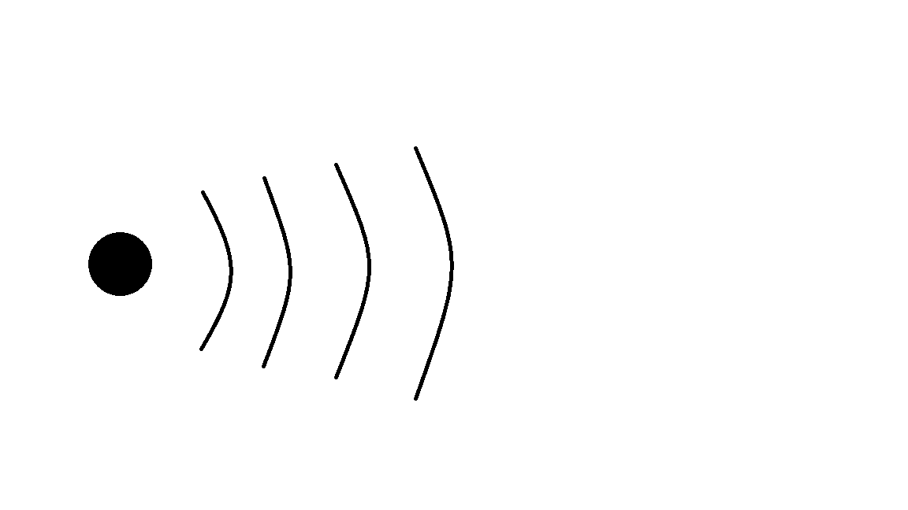

Basic types of attacks

* Swiping attack
* Basic bullet attack (some w/ DOT)
* Stat increase
* AoE attack
* Shockwave >>
* Teleport
* Shield/reflect
* Cross – hair target >>
* Invisibility

